

Key dates
- Soft campaign launch by NHC on 24th July
- NHC Members are invited to get involved from the 25th July
We are excited to be launching the #OurNorth campaign to highlight the great work councils and housing associations are doing across the Northern regions, and what the government must to do to deliver housing policy that really works for the North. We would love you to get involved.
Northern people and places are ambitious – we just need access to the tools to do the job. At the Northern Housing Consortium, we believe the new Prime Minister must do three things:
- Enable the North to raise the quality of our existing housing stock through a flexible regeneration fund.
- Expand the affordable homes programme and ensure it continues to support the North to create great homes and places.
- Create capacity in our councils to realise their housing ambitions
Over the coming months, the NHC will be setting out more detail on each of these priorities. Under the banner of #OurNorth we’ll be telling the story of housing in the North – the opportunity, ambition, and innovation we see every day.
Home to 15million people, #OurNorth is full of opportunity.
Councils and housing associations have ambitious plans to boost the number of homes we build, and the quality of our existing homes. #OurNorth is about celebrating what’s already happening – and highlighting the changes that would enable us to go further and realise our ambitions.
We would love you as NHC members to help us demonstrate the great work you are doing across the North by supporting #OurNorth over social media.

There will be opportunities over the coming months to get involved in all three strands of the campaign. Phase 1 asks the government to expand the affordable homes programme and we would love you to get involved in this.

Supporting the delivery of new affordable homes in the North

#OurNorth is showcasing the great homes and places councils and housing associations have delivered for their communities using Affordable Homes Programme funding. This includes homes for rent, for shared ownership, and for older people.
The North makes a huge contribution to the success of the programme, with one in three Homes England affordable housing completions taking place in the North. These homes contribute to the Government’s overall housing ambitions.
The Affordable Homes Programme plays an important role in the North, particularly as other funds have begun to be geographically targeted on areas of ‘high affordability pressure’. This targeting excludes the vast majority of the North – making the Affordable Homes Programme even more important to our communities.

How to get involved:

Please support us from the 25th July over social media by using #OurNorth and including one or more of our key themes to demonstrate the work you’re doing to improve #OurNorth. We have included a selection of social media post templates and examples below.

You can share case studies of projects delivered with affordable homes programme funding and if you complete the case study template (downloadable here via Dropbox) we will include it on our website and a selection of these case studies will be included in a publication which will be sent to northern MPs and other parliamentarians in the Autumn.

You can also support the campaign with a short piece to camera explaining why the Affordable Homes Programme is so important to the North and how your organisation has benefited from the funding. An example video is included in the assets section of this document.

Our key themes (we encourage you to use your own too!)

- #OurNorth is ambitious (we want to deliver more affordable homes and raise the quality of existing stock)
- #OurNorth is innovative (we are leading the way in boosting quality and productivity through the use of modern methods of construction)
- #OurNorth is inclusive (we are building accessible homes and thriving communities)
- #OurNorth is growing (the North’s population is growing and we need new homes in the North to meet these needs)
- #OurNorth is diverse (our communities have different needs and we need flexible arrangements that can respond to local needs))
- #OurNorth is ageing well (as our ageing population grows in the north we are adapting existing homes and building new ones where northerners can age well)

Social media
Please use the hashtag #OurNorth with any of the themes above and answer the question - why is the Affordable Homes Programme so important to the North of England?’ Template posts can be seen below – please reword as appropriate.

Twitter (please include the @nhc so that we can retweet your tweets!)

Example tweets:

Launch day (Thursday 25th July):

We are supporting the #OurNorth campaign with @nhc which launches today - highlighting the great work of housing organisations across the North and what the government must to do to deliver housing policy that really works for the North. Find out more here: http://bit.ly/2JU9Nol

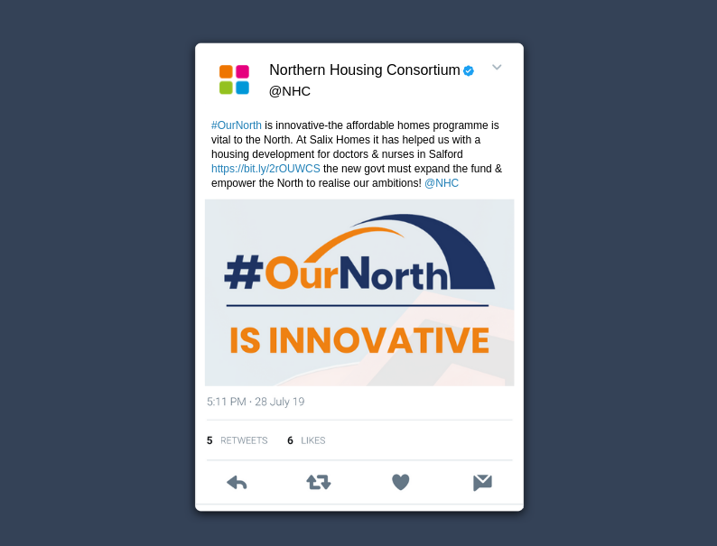

Launch day or any other day from the 25th July
#OurNorth is [choice of theme]-the affordable homes programme is vital to the North. At [organisation name] it enabled us to……. that’s why the govt must expand the fund and empower the North to realise our ambitions! @nhc

LinkedIn template post

#OurNorth is showcasing the great homes and places we have delivered for our communities using Affordable Homes Programme funding.
The North makes a huge contribution to the success of the programme, these homes contribute to the Government’s overall housing ambitions – and we’re ambitious to do more.
At [organisation name] it enables us to…… That’s why the government must expand the fund and empower the North to realise our ambitions.

Assets for the campaign
- #OurNorth logo: http://bit.ly/2YiaBN8
- #OurNorth transparent logo: http://bit.ly/2M5Q9Zm #
- NHC logo - http://bit.ly/2LBuQiB
- Twitter theme templates (these assets have a transparent background so can have an image behind if the background image is made slightly transparent)
Ambitious – http://bit.ly/2ObzDK0
Innovative – http://bit.ly/32FBxpr
Inclusive – http://bit.ly/2GBc47d
Diverse – http://bit.ly/32J8cug
Growing - http://bit.ly/32Mn8YC
Ageing Well - http://bit.ly/2Z49qxK
- Link to example video - http://bit.ly/2JTCkKI

